

# Lab-5.0.1

# Visual Studio Code Installation

# Lab Objectives

In this lab you are going to install Visual Studio Code which is going to be used during the module.

# Tasks

1. Go to the ubuntu store by clicking on the icon:



1. Search for “vscode” and install it:

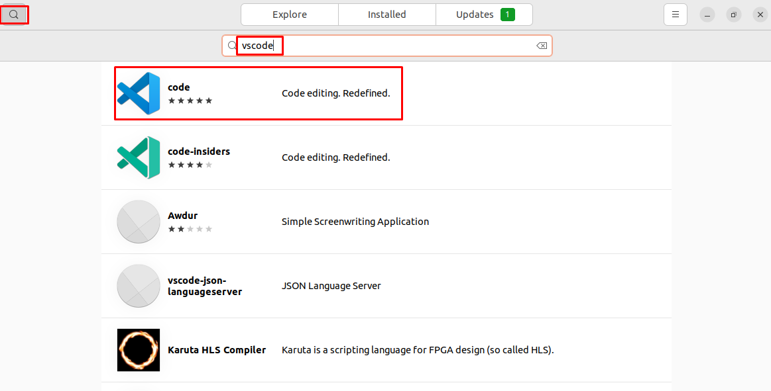

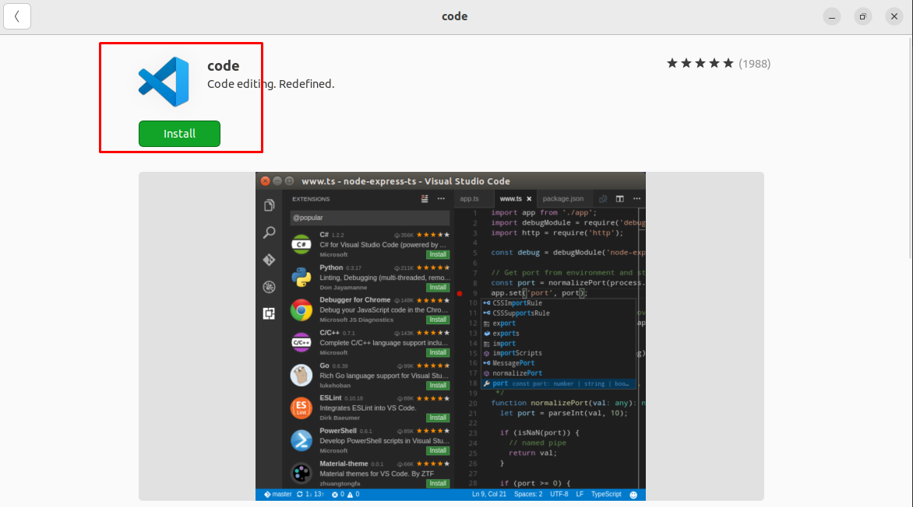

1. It will ask for a password of your user.
2. Once installed open it by pressing the windows key and searching for “code”:

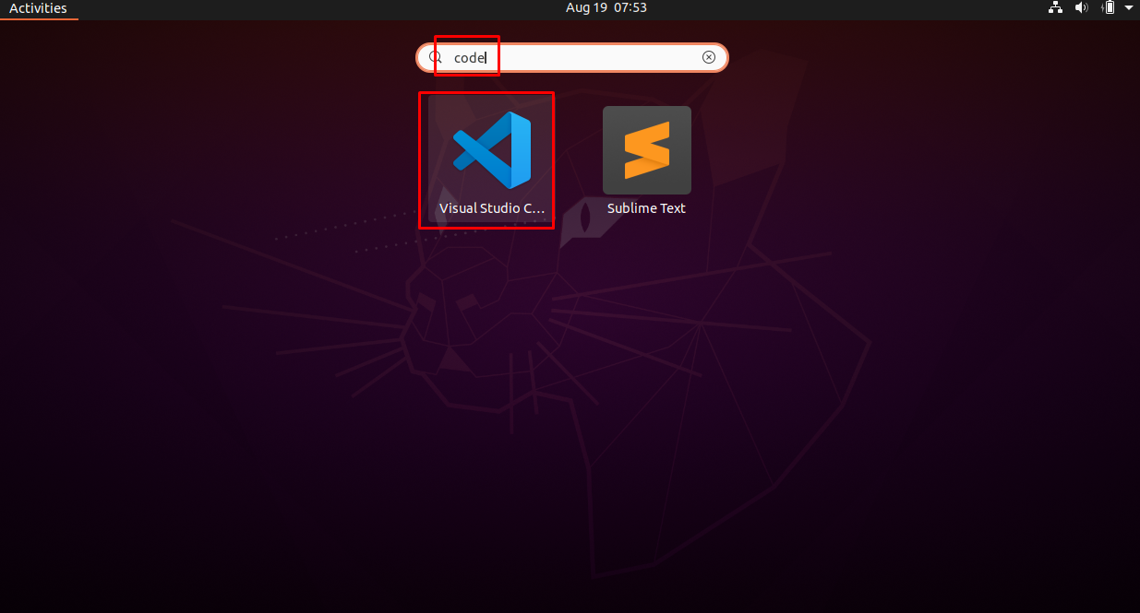

1. Pick a theme and press “Mark done”

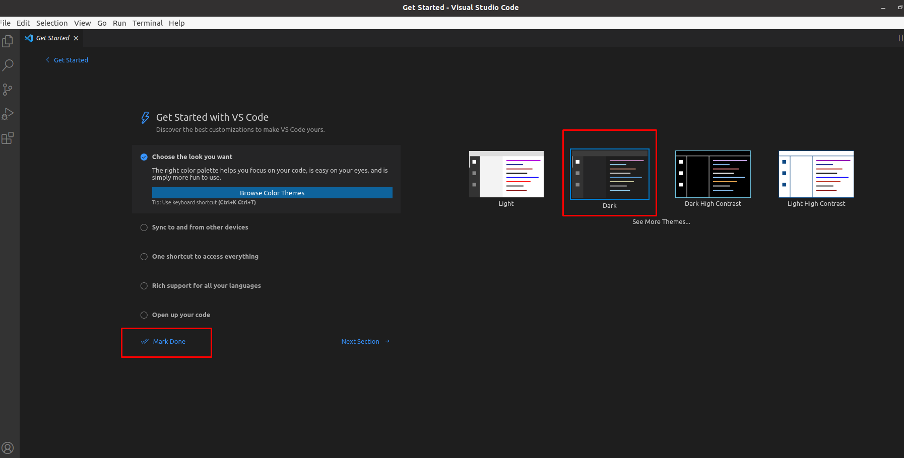

1. Click on extensions:

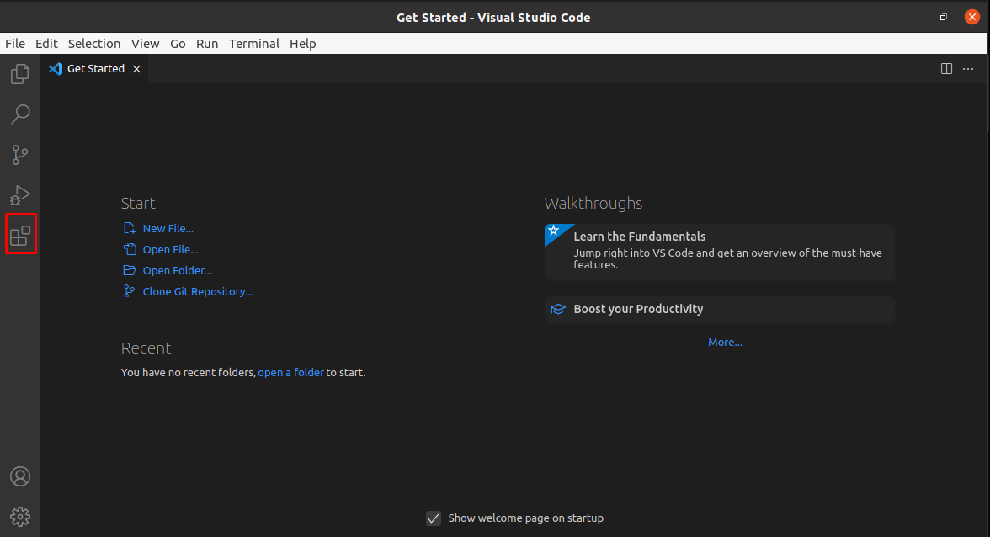

1. Search for and install python – and you’re done!

